# Data scenarios and responses

Being able to communicate in multiple formats is a key skill for data analysts. Listening, speaking, presenting, and writing skills will help you succeed in your projects and in your career. This reading covers effective communication strategies, including examples of clearly worded emails for common situations.

Here's an important first tip: Know your audience! When you communicate your analysis and recommendations as a data analyst, it's vital to keep your audience in mind.

Be sure to answer these four important questions related to your audience:

1. Who is your audience?
2. What do they already know?
3. What do they need to know?
4. How can you best communicate what they need to know?

## Project example

As a data analyst, you'll get plenty of requests and questions through email. Let’s walk through an example of how you might approach answering one of these emails. Assume you're a data analyst working at a company that develops mobile apps. Let's start by reviewing answers to the four audience questions we just covered:



Kiri, Product Development Project Manager



Kiri received updates about our project from its planning stages, including the most recent project report, sent two weeks ago.

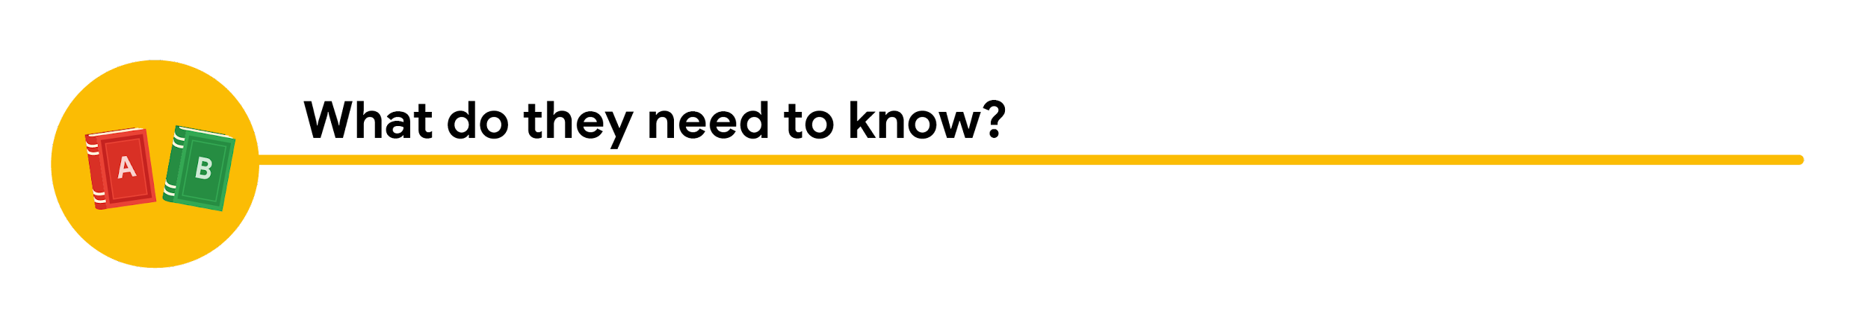

Kiri needs an update on the analysis project’s progress and needs to know that the executive team approved changes to the data and timeline. You know that adding a new variable to the analysis will impact the current project timeline. Kiri will need to change the project’s milestones and completion date.

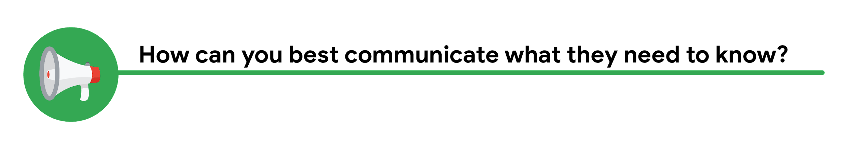

You can start by sending an email update to Kiri with the latest timeline for the project, but a meeting might be necessary if she wants to talk through her concerns about missing a deadline.

## Updated timeline email sample

After answering the audience questions, you have the key building blocks you need to write an email to Kiri. Here's an example of how these questions can help organize the flow of the email message:

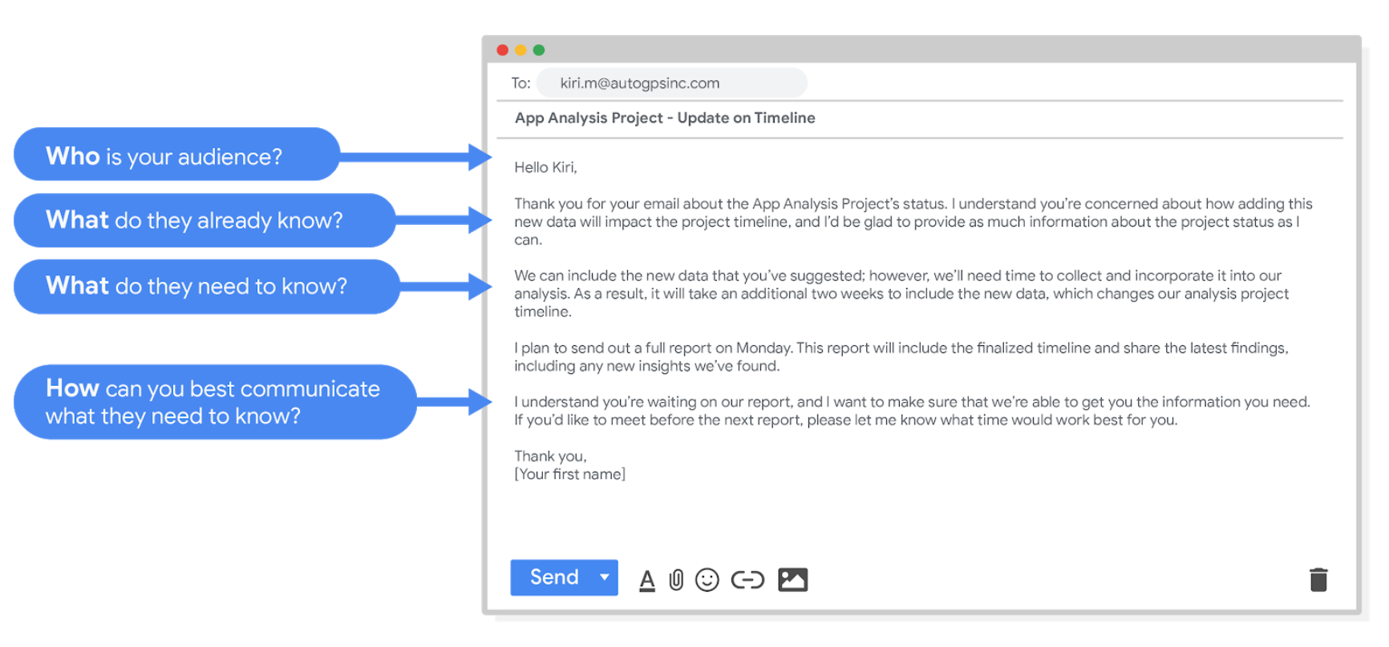

Hello Kiri, (who is your audience?)

Thank you for your email about the app analysis project's status. I understand you're concerned about how adding this new data will impact the project timeline, and I'd be glad to provide as much information about the project status as I can. (What do they already know? )

We can include the new data that you've suggested however, we'll need time to collect and incorporate it into our analysis. As a result, it will take an additional two weeks to include the new data, which changes our analysis project timeline. (What do they need to know?)

I plan to send out a full report on Monday. This report will include the finalized timeline and share the latest findings, including any new insights we've found.

I understand you're waiting on our report, and I want to make sure that we're able to get you the information you need. If you'd like to meet before the next report, please let me know what time would work best for you. (How can you best communicate what they need to know?)

Thank you,

(your first name)

After receiving your email, Kiri will have a clearer view of the changes to the analysis project and will be able to make adjustments to work with the new timeline.

## Project follow-up email sample

After the next report is completed, you can also send out a project update offering more information. The email could look like this:

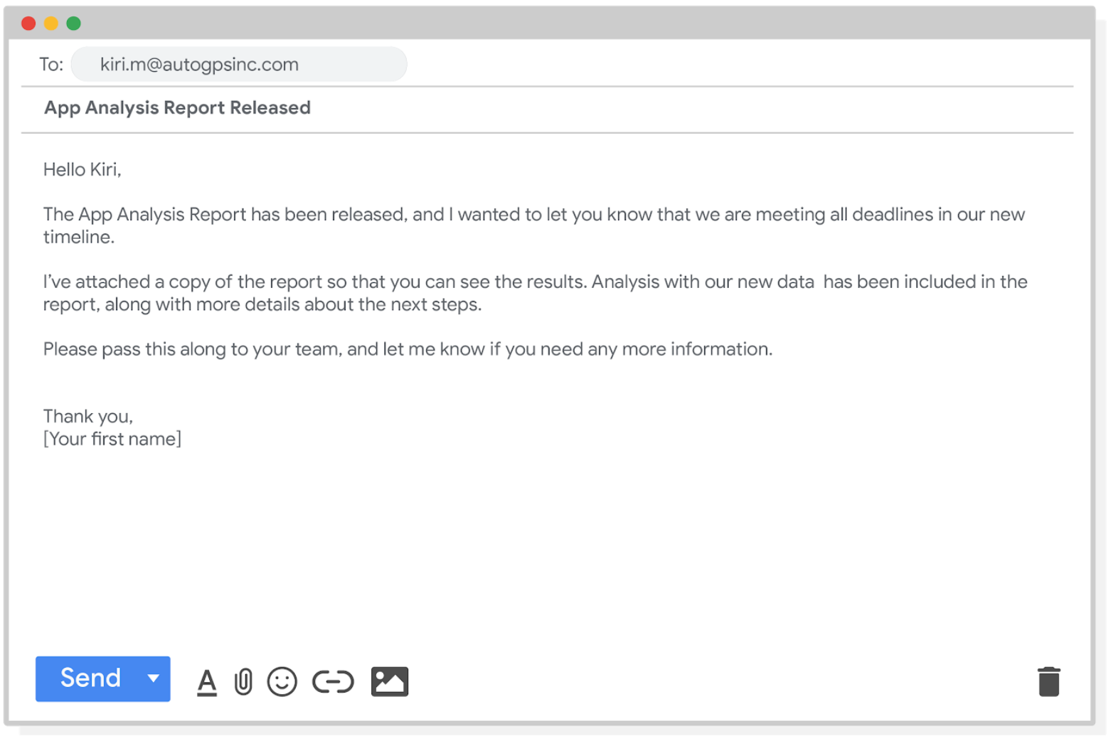

Hello Kiri,

The app analysis report has been released, and I wanted to let you know that we are meeting all deadlines in our new timeline.

I've attached a copy of the report so that you can see the results. Analysis with our new data has been included in the report, along with more details about the next steps.

Please pass this along to your team, and let me know if you need any more information.

Thank you,

[your first name]

Good communication keeps stakeholders updated on progress and ultimately helps prevent problems. Carefully worded responses are key. Whether you gather and address feedback using email, meetings, or reports, everyone you work with will know what to expect. As a result, they will be able to better manage their own schedules, resources, and teams.